I. Conceptualizing Data Analysis as a Process
- Definition: Data analysis is the systematic transformation of raw data into meaningful insights that inform decisions.
- Expanded Explanation:
  - It is not a single act but a framework that integrates problem definition, data collection, cleaning, analysis, interpretation, and communication.
  - Each stage requires judgment, technical skill, and contextual awareness.
- Diagram (Conceptual Flow):
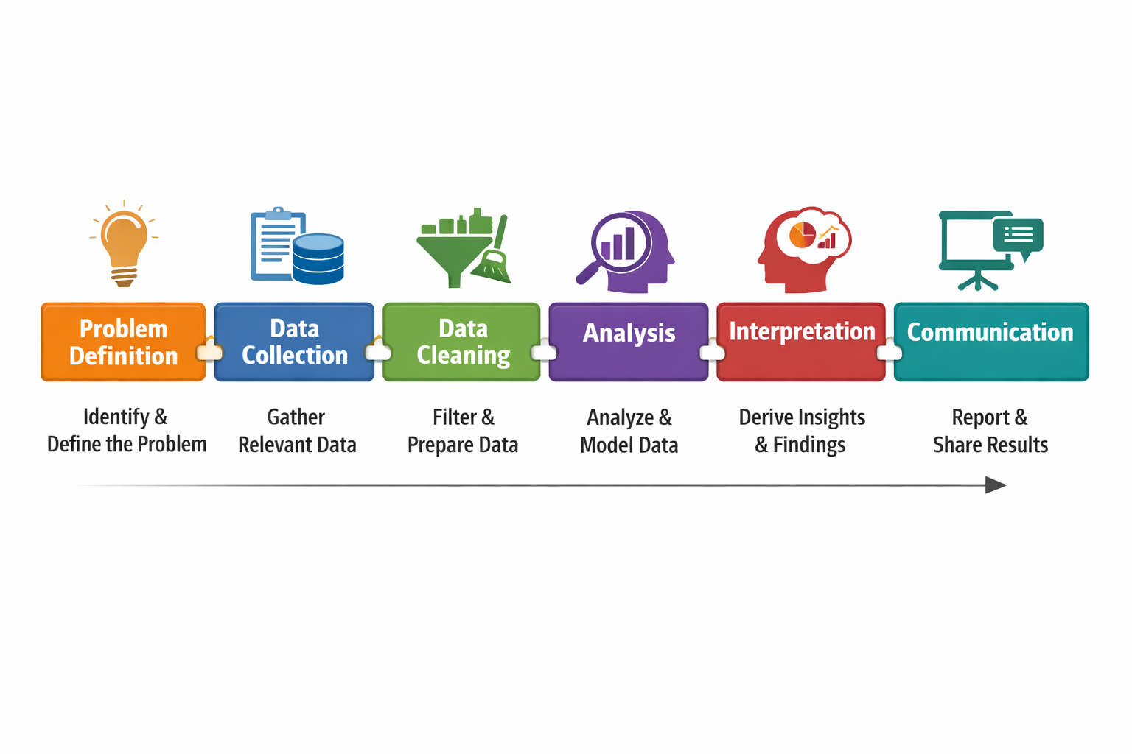
- Key Insight: Viewing analysis as a process ensures transparency, replicability, and strategic alignment.
II. The “Problem” with Data Analysis
- Definition: The challenges and misconceptions that undermine effective analysis.
- Expanded Issues:
  - Bias: Analysts may unconsciously frame questions to confirm expectations.
  - Over-technical focus: Treating analysis as purely statistical, ignoring context.
  - Data Quality: Missing, inconsistent, or irrelevant data reduces validity.
  - Communication Gap: Results may be too technical for decision-makers.
- Diagram (Problem Areas):
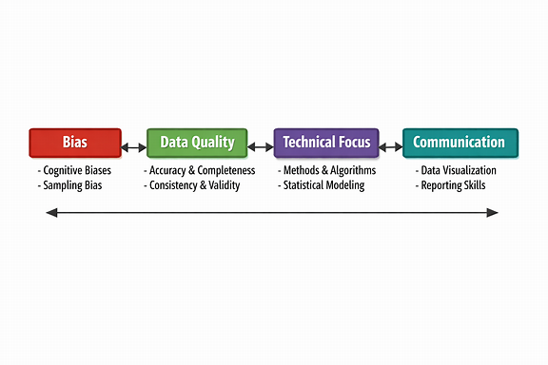
- Implication: Safeguards such as diverse teams, iterative review, and clear reporting are essential.
III. Data Analysis as a Linear Process
- Definition: A step-by-step, one-directional approach.
- Expanded Explanation:
  - Steps: Define → Collect → Analyze → Report.
  - Strengths: Simple, structured, easy for beginners.
  - Weaknesses: Rigid, does not allow revisiting earlier steps.
- Diagram:
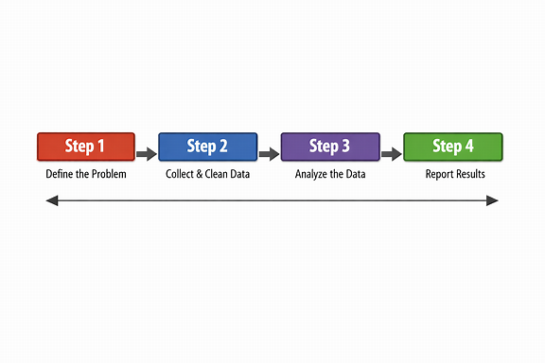
- Example: A one-time survey project with fixed questions and a single report.
IV. Data Analysis as a Cycle
- Definition: An iterative approach where steps are revisited.
- Expanded Explanation:
  - Steps: Define → Collect → Analyze → Interpret → Refine → Repeat.
  - Strengths: Flexible, adaptive, suited for complex problems.
  - Weaknesses: Requires more time and resources.
- Diagram:
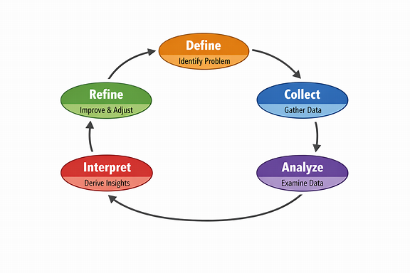
- Example: Policy evaluation where findings generate new questions.
V. Managing the Data Analysis Process
1. Developing a Team
- Definition: Building a group with complementary skills.
- Expanded Explanation:
  - Roles:
  - Data Collectors – ensure accuracy in gathering information.
  - Statisticians/Analysts – apply methods and interpret results.
  - Domain Experts – provide contextual knowledge.
  - Writers/Communicators – translate findings for stakeholders.
  - Reviewers – ensure quality and reduce bias.
- Diagram:
Team = (Technical Skills + Domain Knowledge + Communication Skills)
2. Planning
- Definition: Establishing objectives, scope, and timelines before analysis begins.
- Expanded Explanation:
  - Objectives: What questions are being answered?
    - Must be SMART (Specific, Measurable, Achievable, Relevant, Time-bound).
    - Example: “Evaluate student performance trends over 5 years.”
  - Scope: What data sources, methods, and boundaries are included?
    - Define inclusion/exclusion criteria.
    - Example: “Include exam scores from 2018–2023; exclude incomplete records.”
  - Timeline: When tasks will be completed, milestones, deadlines.
  - Use Gantt charts or milestone tracking.
  - Example: “Data collection by Week 2, cleaning by Week 4, analysis by Week 6.”
- Diagram (Planning Pyramid):
Objectives ↓ Scope ↓ Timeline
- Implication: Strong planning prevents wasted effort and ensures alignment with institutional goals.
3. Data Management
- Definition: Organizing, cleaning, and storing data for reliability.
- Expanded Explanation:
  - Data Cleaning: Handle missing values, correct errors, remove duplicates.
  - Data Coding: Standardize formats for analysis (e.g., numeric codes for categories).
  - Data Storage: Secure, accessible, documented for reproducibility.
- Diagram:
Raw Data → Cleaning → Coding → Storage → Analysis
- Best Practices:
- Maintain metadata (data about data).
- Use version control for datasets.
- Ensure compliance with privacy/ethical standards.
4. Writing
- Definition: Communicating findings effectively.
- Expanded Explanation:
  - Structure:
    - Introduction – context and objectives.
    - Methods – how data was collected and analyzed.
    - Results – key findings with visuals.
    - Discussion – interpretation and implications.
    - Conclusion – summary and recommendations.
  - Audience: Tailor language for technical vs. non-technical readers.
  - Tools: Use visuals (charts, graphs, tables) to simplify complex results.
- Diagram:
Data → Findings → Report → Audience Understanding
5. Evaluation
- Definition: Assessing the quality and impact of the analysis.
- Expanded Explanation:
  - Quality Check: Were objectives met? Was data reliable?
  - Impact Assessment: Did findings influence decisions?
  - Lessons Learned: What can be improved for future projects?
- Diagram:
Analysis → Evaluation → Improvement → Next Cycle
- Best Practices:
- Conduct peer review.
- Compare outcomes with benchmarks.
- Document feedback for continuous improvement.

